**(Please check one)**

Have you taken the online Career Assessment?

**YES___ NO___**

If YES, please choose a job that matches your interests.

Your job is **______________________**.

If NO, we will call to schedule a time for you to take the Career Assessment before the Real World Event.

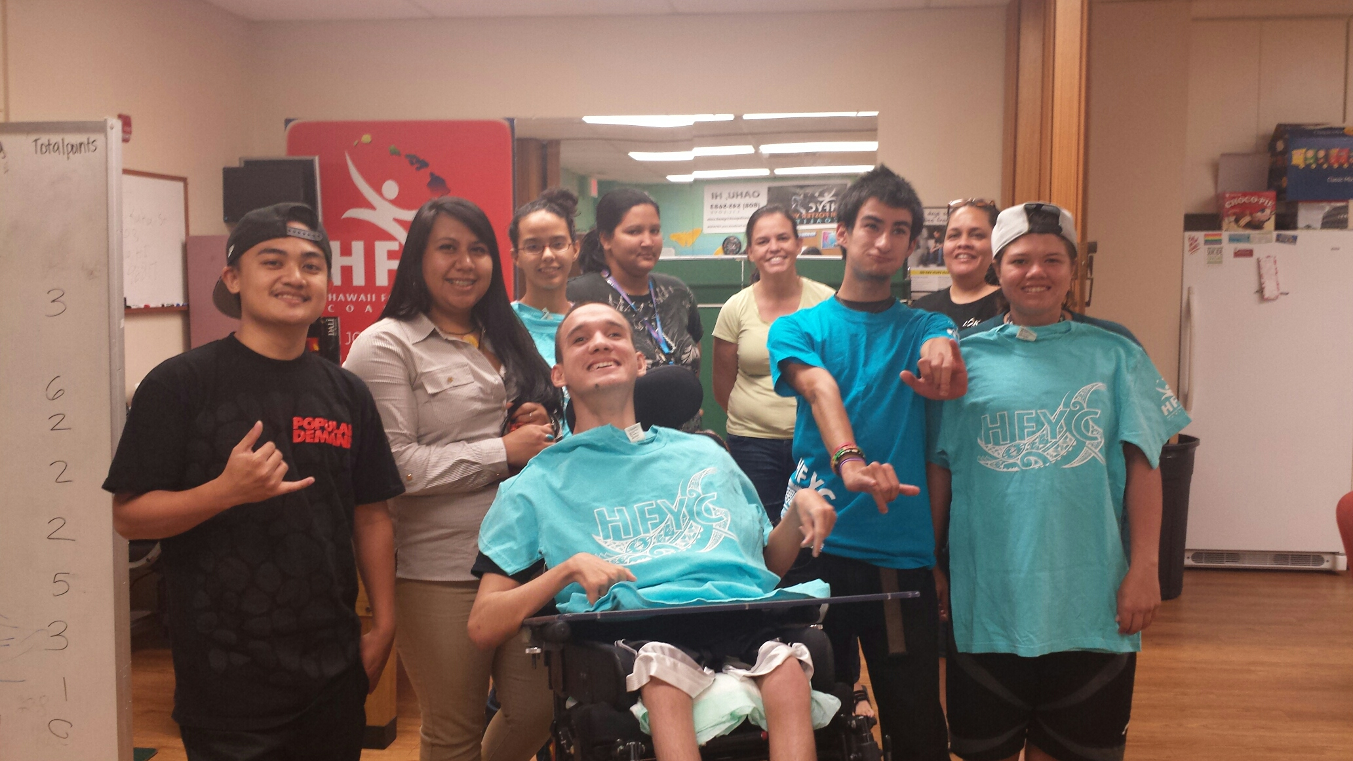

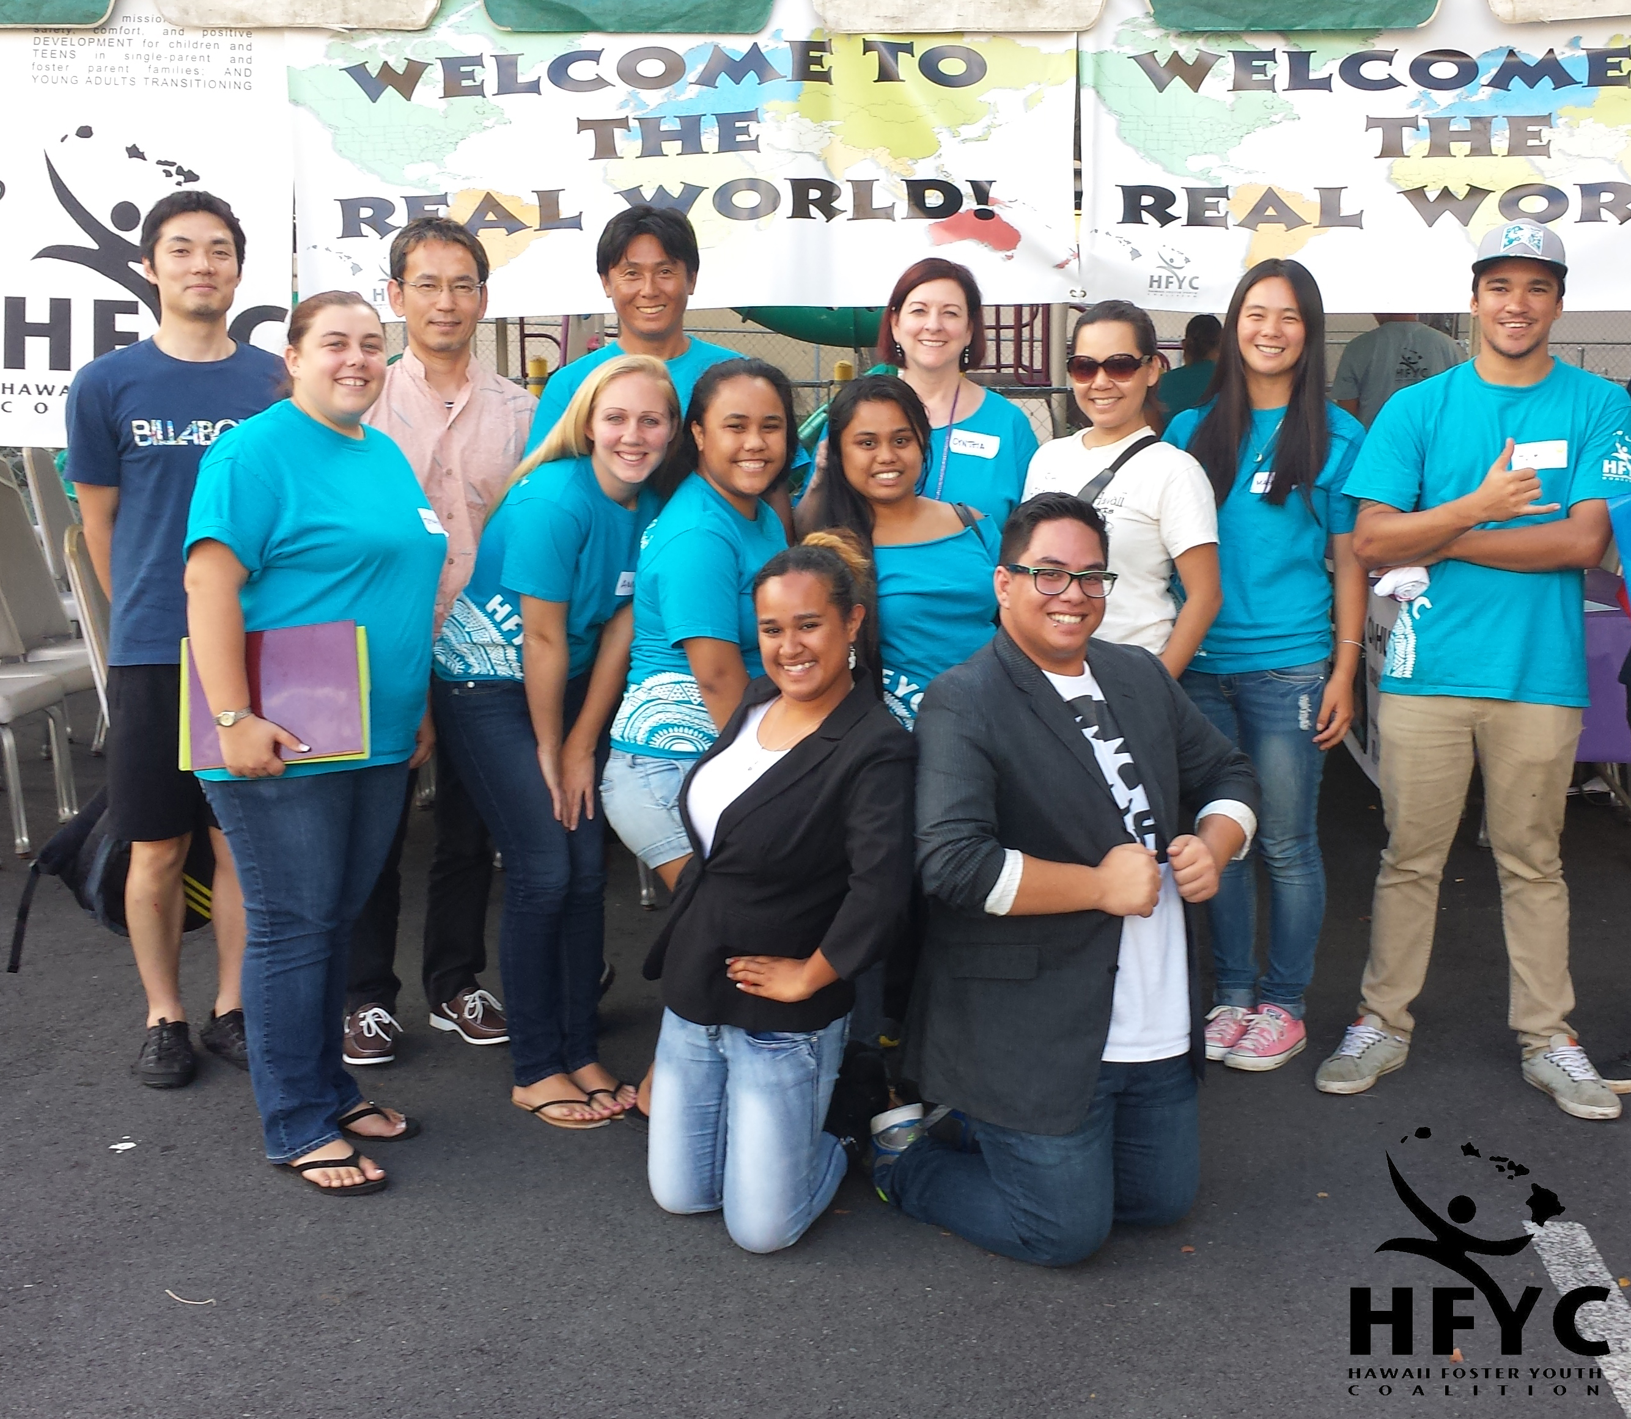

**Real World Media Consent**

(If yes, please check the box and initial here) _______

⇨ I allow the Hawaii Foster Youth Coalition to use pictures and videos that are taken during the activities and agree for them to be used in newsletters, brochures, and/or social media.

**If under 18 please have Parent/ Legal Guardian initial**

**REAL WORLD**

**May 2nd, 2015**

**REGISTRATION FORM**

**Ages 16- 21 years old**

_______________________________________________________________________________________

**Youth Signature Date**

_______________________________________________________________________________________

**Parent/Legal Guardian Signature (If under 18)** **Date**

**Fax Form to HFYC Office, 808-545-5417; for more information call 545-5683 (LIL-LOVE).**

**Or Mail to 245 N. Kukui St. Ste. 203, Honolulu HI, 96817 by: April 17, 2015**

**Create A Dream For Your Future & A Path To Success.**



**SPONSORED BY**

**THANK YOU**

**Co-sponsors**

Na Lei Aloha, Office of Youth Services, Watumull Fund, Kids Hurt Too Hawaii, Global Consulting, Inc., and Altres

**Entertainment & Prizes**

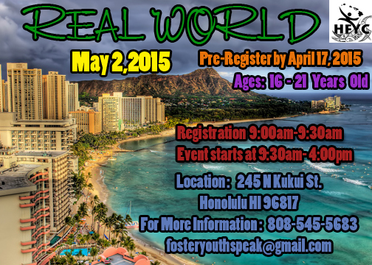

**Print Name: _______________________________**

**Birth date: _________ Special needs: __________**

**__________________________________________**

**__________________________________________**

**Address / City / State / Zip Code**

**__________________________________________**

**Phone Email**